

Press Kit

Welcome to ***HellEscape*** Press Kit. If you need any additional information or assets, please let us know in the contact email.

FACT SHEET

Game Name: HellEscape

Developer: Ronen Ness

Early Access Since: 18 Sep, 2022

Full Release Date: Mid 2023

Price: $3.99 USD

ESRB: Everyone

Genre: Roguelike, Shoot 'em up

Available On: [Steam](https://store.steampowered.com/app/2135030/HellEscape/)

Contact Me: [ronenness@gmail.com](mailto:ronenness@gmail.com)

Description

***HellEscape*** is a beautiful top-down shoot ‘em up with roguelike elements and brutal gameplay. It has tons of unique enemies with different abilities to face, and a roster of 19 heroes each wielding a different set of weapons and special abilities.

The game is inspired by games like *Vampires Survivors* and *Magic Survivors*, and can definitely satisfy one’s thirst for the genre, but it is also vastly different and introduces a fresh new mission-oriented approach to the formula.

In ***HellEscape*** you’ll fight for survival through eight stages, each coming with a different biome, unique enemies, and six levels to complete. These levels include survival missions, item collecting challenges, protecting target missions, breaching an enemy fortress, and many more. Every stage ends with a powerful boss that must be defeated in order to unlock the next stage.

To season up the stages, ***HellEscape*** alsoprovides a randomly-generated ‘Daily Challenge’ that mixes together a random mission with a unique quirk for an extra layer of difficulty. These quirks include things like an immortal deadly snail that hunts the player, a meteor shower ravaging the battlefield, a broken magnet that pushes loot away, and much more.

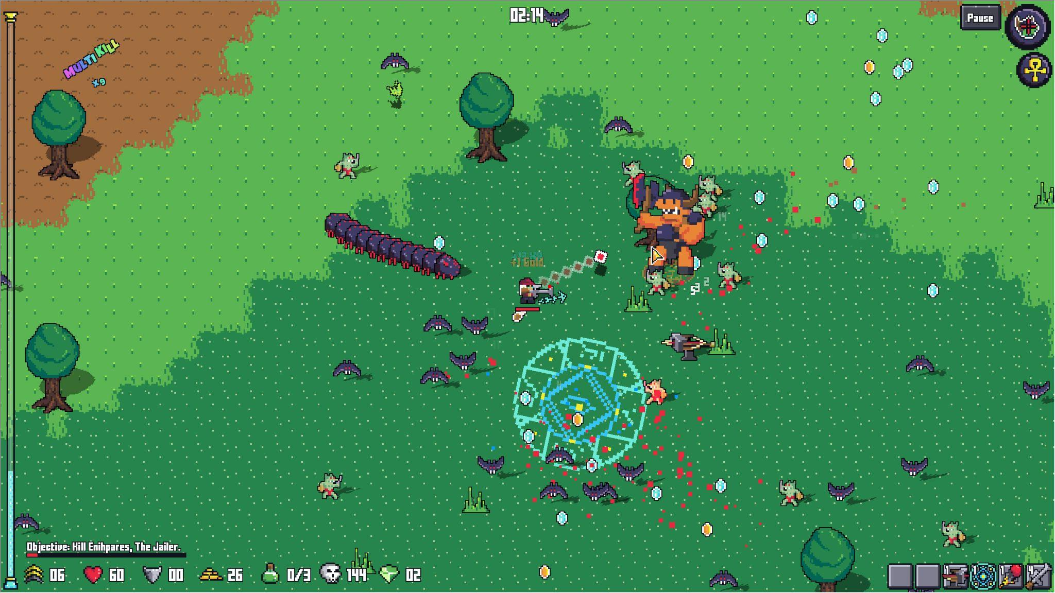

Plot

At first glance, the narrative of ***HellEscape*** seems quite simple. You fight a horde of monsters, who presumably escaped from hell (as the name implies), and your goal is to stop them. Easy. But actually, completely wrong.

As the player progresses through the stages, they will find mysterious artifacts called ‘Pacts’, that reveal cryptic messages in their description. Following these messages will uncover a grim truth about the nature of the game itself, a secret that will come to a conclusion in the final stage.

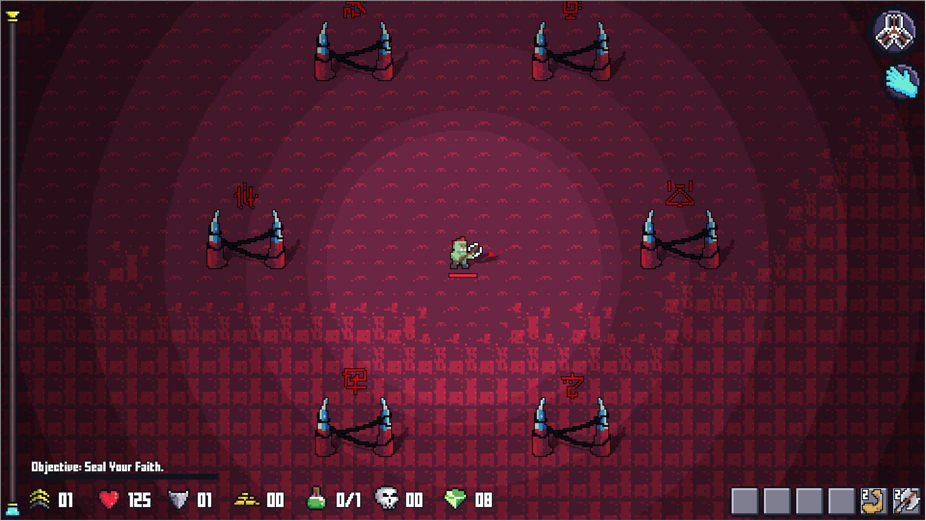

Features & Game Mechanics

Controls

***HellEscape*** is a twin-stick shooter, i.e. players can aim and move separately, and dash around the battlefield. The game supports keyboard, mouse, and gamepad.

Dry Stats

At the time of writing this press kit, ***HellEscape*** has:

* 8 Stages with total of 48 Missions
* 19 Heroes
* 36+ Artifacts
* 87 Skills (15 of which are passives)
* 60+ Power Ups (with total of 152 levels to unlock)
* 70+ Monster Types
* 295 Achievements (30 on Steam)

Heroes & Special Abilities

The game features 19 playable heroes to unlock by completing achievements.

Every hero has different stats, set of skills they can learn, and a unique power they can trigger by collecting mana potions. For example, the Mage can stop time for a few seconds, the Knight gets a super-shield buff, the Witch Doctor turns into a Werewolf, Ranger brings down a rain of Arrows, etc.

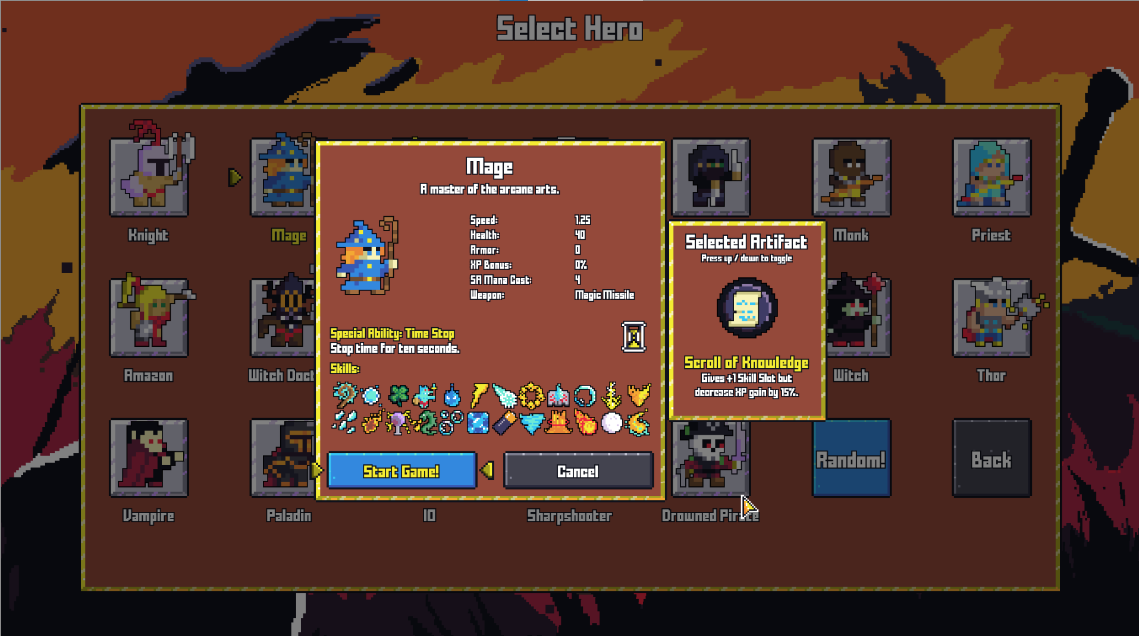

Artifacts

Players can find special artifacts that give special abilities or passive bonuses. These artifacts can be utilized to aid with specific challenges or to empower heroes.

Loot

There are many items to loot from fallen enemies: XP, Gold, Food, Gems, Blood, Boots, Mana Potions, Blades, Armor, Skill Level Ups, and more. Every loot item is valuable in its own way, and collecting them can be crucial to the success of the mission.

Powerups

Players can use gold to unlock special power ups, which are persistent between runs. These include passive power ups that improve heroes stats, special abilities like reroll or banish skills, power ups that enhance existing skills, and power ups that add new game mechanics (like spawning chickens you can hunt for health, and later explode on your enemies).

There are also slightly less orthodox power ups, like the ‘Gigachad’ that permanently cuts your heroes health in half to make the game even harder, or the ability to get free gold in exchange for performing real-life workout sets. Yep, that’s a thing.

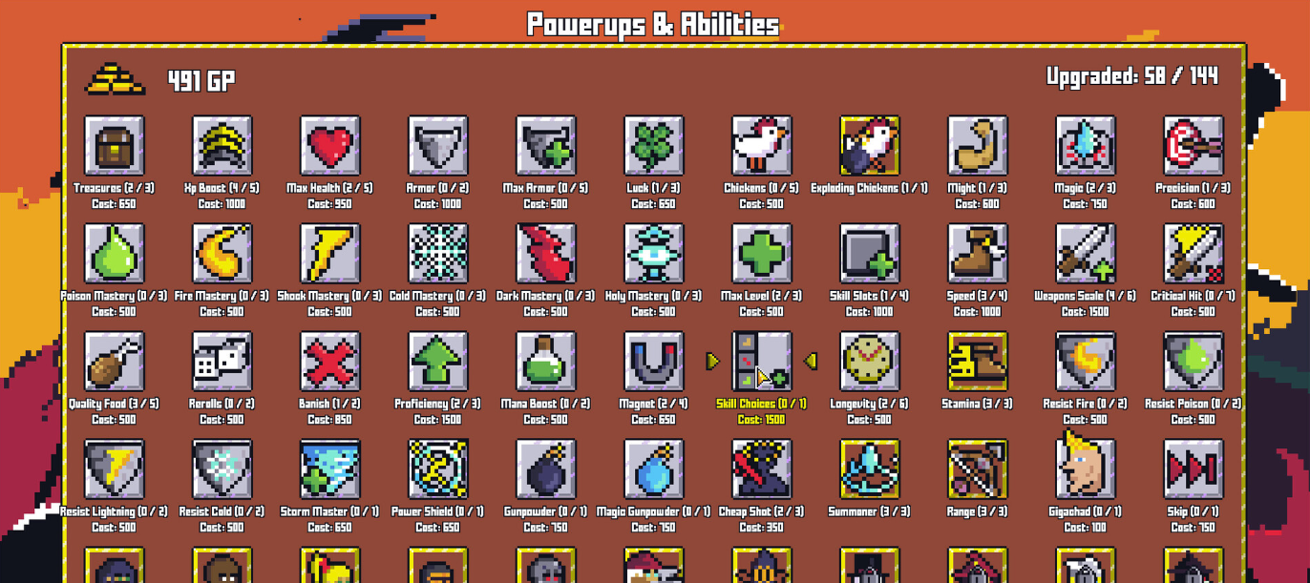

Media

Open an image in a new tab to view it in full size.



